#color Scheme

navbar - #917FB3

Body Background - #E5BEEC

Footer - #2A2F4F

#Fonts

Buttons, navbar & footer - montserrat(bold)

content headings - Playfair Display

content bodies - proxima-nova, sans-serif

#Designs

NAVBAR



options will include

\*Logo with project name “OpenBlog”

\*Services

\*Plans & Pricing

\*About Us

\*Contact Us

#Right Side

\*Login

\*SignUp

Navbar Shouldn’t Hide when scrolling. And z-index should be max.

.....................................................................................................

#Body

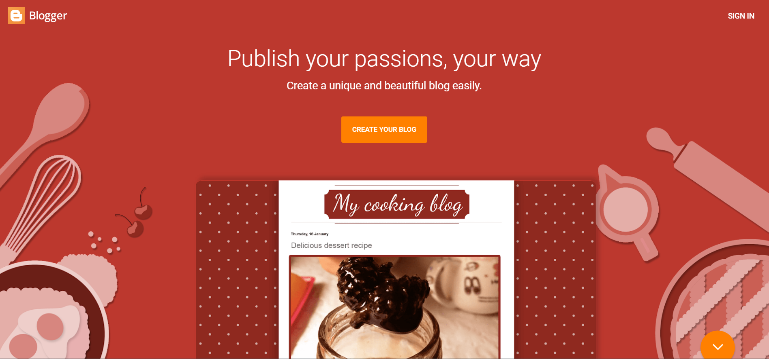

Center a cool line with a button below saying “Publish your first Blog”.

Height 100vh.

All site features will be explained here in brief either with separate blocks like:

All content will be placed inside a vertical Flex to contain with width of 75-80%(your choice).

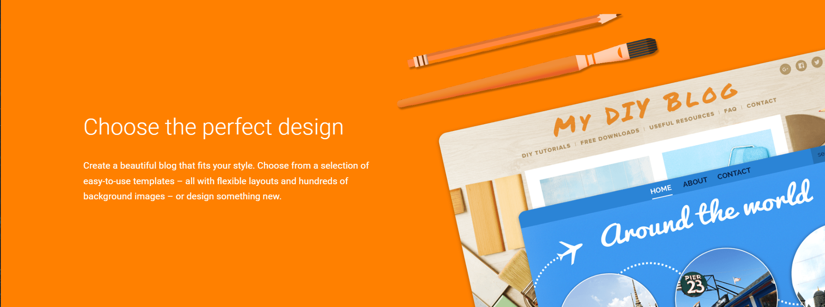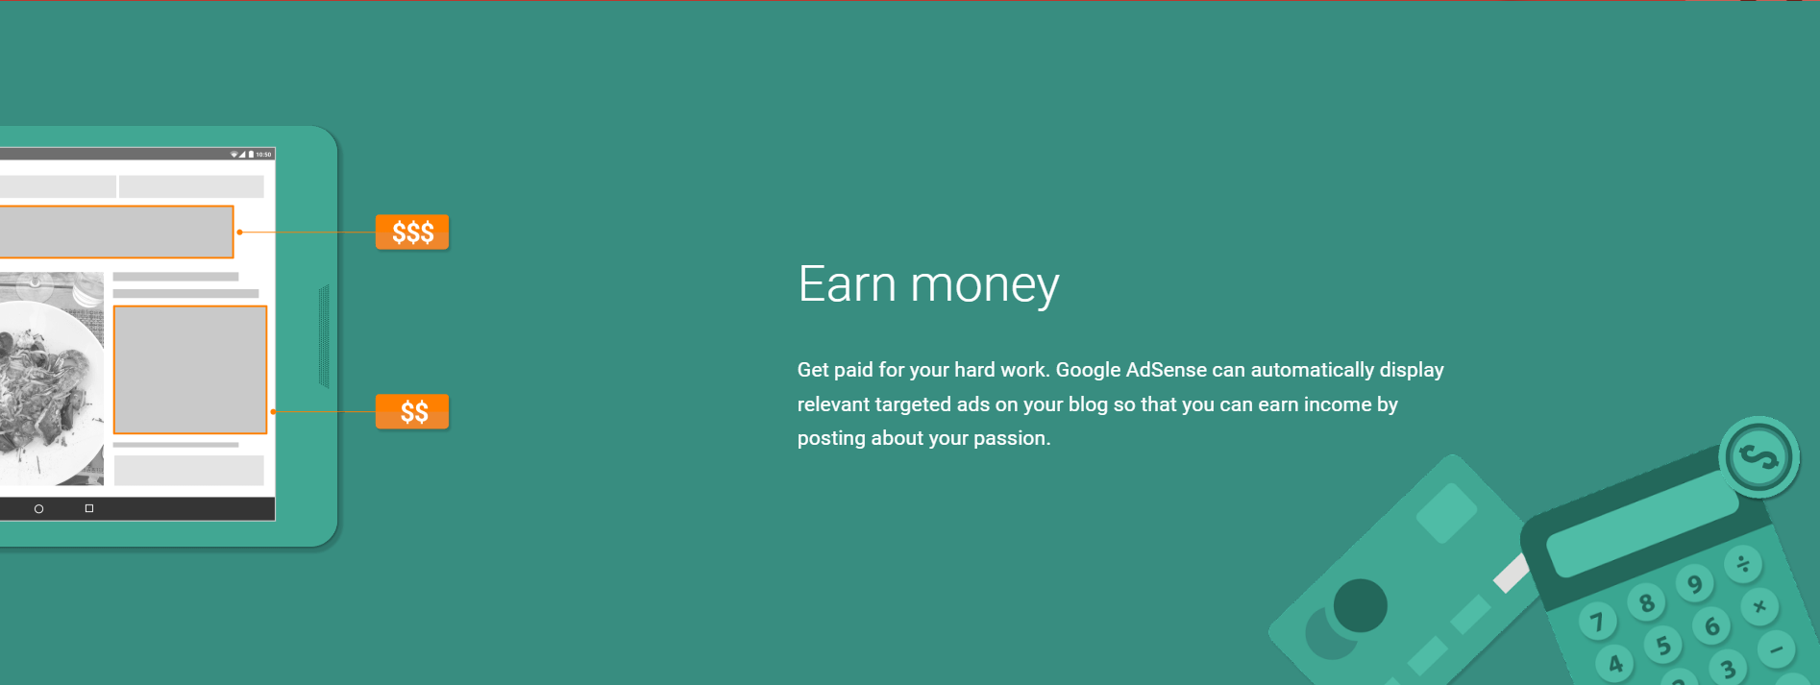

Or Use A single block to feature everything:

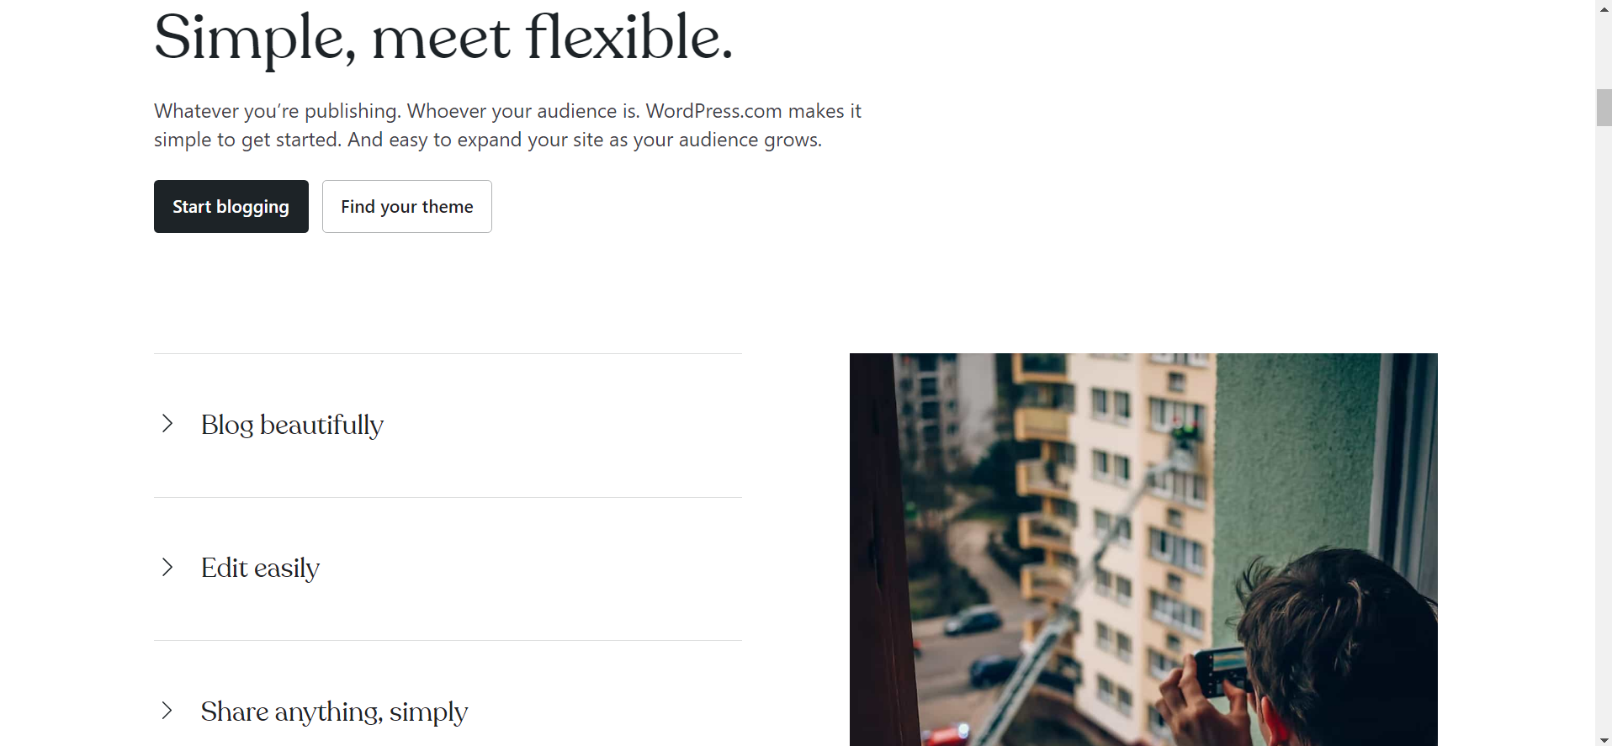

#Body Second Half

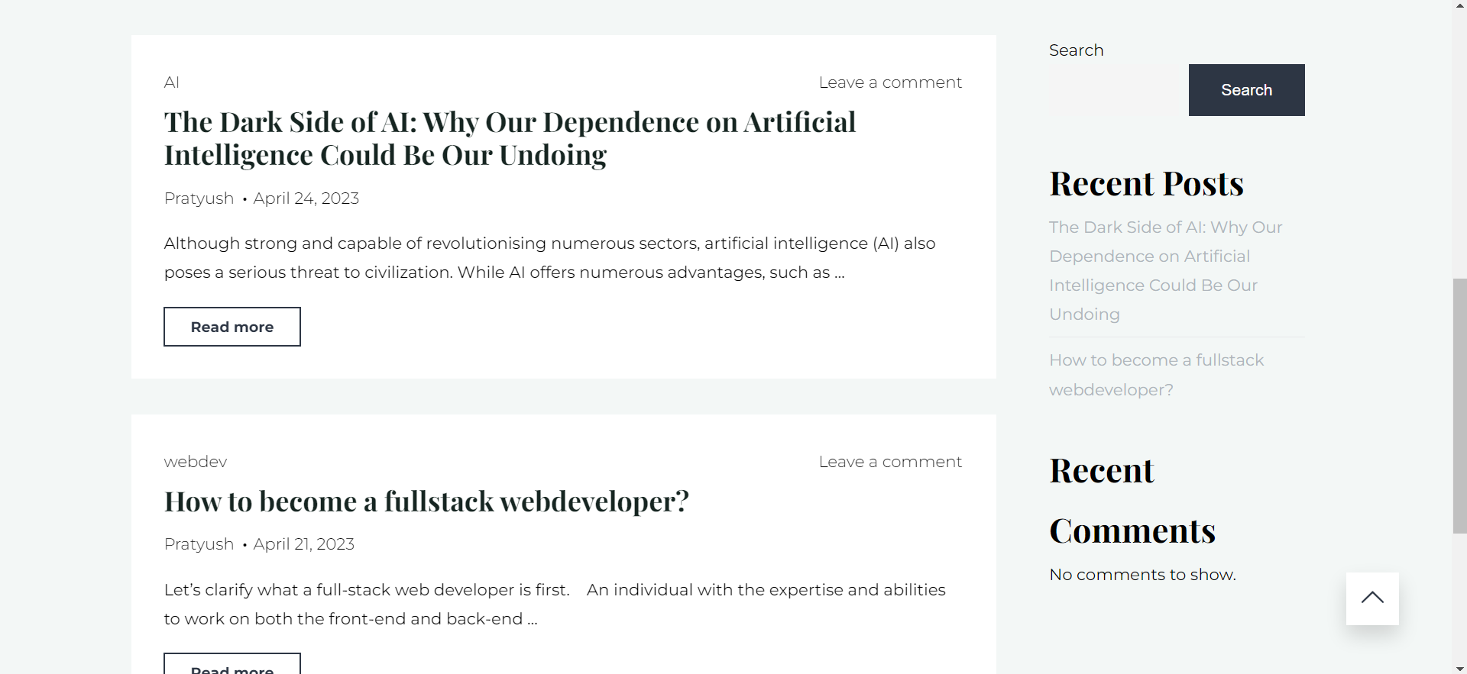fdssd

Again Use the same body containing flex to section further into two parts.

You can use grid for that.

#Left side will show :

The Article heading

Publisher Name

Article body(200 characters)

A read More button linking to solo page view.

#Right side will show:

“Recent Uploads” heading for a section

All article Headings (30 Characters).

Don’t Include The share Bar

#Footer

Choose the defined color scheme and fonts .

( Or feel free to Improvice)

Put some dumy content bar in that .

For Refrence:

